CT500 PCB Application Note

Version 1.0

Shmt Co., Ltd.

REVISION HISTORY PAGE

Issue | Rev No. | Originator | Details of Change | Date
1 | 1.0 | EAST | Initial Version | 2007-06-13
2
3
4
5

Technical documents for Firmware

Copyright © 2007 Shmt Limited. All rights reserved.

Confidentiality Status
This document is NOT OPEN ACCESS. The distribution is restricted to certified company.
This document is CONFIDENTIAL.

Feedback on this document
If you have any comments on this document, please contact your channel to our company.

Shmt Web address
http://www.shmt.com

Contents

1. INTRODUCTION 7
2. Reference Application 8
2.1. Power On/Off Sequence 8
2.2. PLL Application 9
2.3. DDR Application 11
2.4. ARM ICE Application 13
2.4.1. Signals 13
2.4.2. Schematic 13
2.5. USB Application 15
2.5.1. Board Application 15
2.5.2. PCB Layout 16
2.6. DAC Application 18
2.6.1. Overview 18
2.6.2. Block diagram 19
2.6.3. Operation 20
2.6.4. PCB guidelines 22

Figures

Figure 3- 1 Power On/Off Sequence 8
Figure 3- 2 PLL Connection Diagram 9
Figure 3- 3 Tank Circuit for the Fundamental Mode Oscillation 9
Figure 3- 5 SSTL2 POC signal waveforms 11
Figure 3- 6 SSTL2 Class I termination configuration 12
Figure 3- 7 MultiICE pin connections 13
Figure 3- 8 PCB Schematic 15
Figure 3- 9 PCB Layout for USB 2.0 signal lines 16
Figure 3- 10 Space of USB 2.0 signal lines 16
Figure 3- 11 Component to USB 2.0 signal lines 17
Figure 3- 12 USB 2.0 signal and ground plane 17
Figure 3- 13 USB Crystal 17
Figure 3- 14 Video DAC Diagram 19
Figure 3- 15 mode1/2 iref connection 20
Figure 3- 16 mode4 iref connection 21
Figure 3- 17 power supply decoupling 22
Figure 3- 18 simple configuration to implement output to voltage conversion 23
Figure 3- 19 34mA output configuration to convert current to voltage (Normal) 23
Figure 3- 20 17mA output configuration to convert current to voltage 24
Figure 3- 21 Reference guideline 24

Tables

Table 3- 1 PLL Power Description 9
Table 3- 2 Pin Name of SSTL2 Power and Ground Cells 11
Table 3- 3 MultiICE signals 13
Table 3- 4 USB Pin Name Mapping 15
Table 3- 5 Operation mode 20

INTRODUCTION

본 문서는 CT-500의 Board reference application과 ㈜상화마이크로텍에서 제공하는 CT500 SOC의 PCB application에 대한 내용을 다룬다.

Reference Application

Power On/Off Sequence

CT500 has multiple power domains as following:

- IO Power domains
  - SSTL IO power domain(2.5V)
  - General IO Power domain(3.3V)
- Core Power domains(1.2V)
- PLL Power domain(1.2V)

Power-Up Sequence
The power up sequence MUST be in the order of turning on higher voltage first, then turning on core voltage afterwards.

Power-Down Sequence
The POC circuit is only functional during the power-up sequence, and would not work during the power-down sequence. However, to save the transient current that consumes power, the lower voltage (VDD) should be powered down first and then the higher one (VDDPST).

Figure 3- Power On/Off Sequence
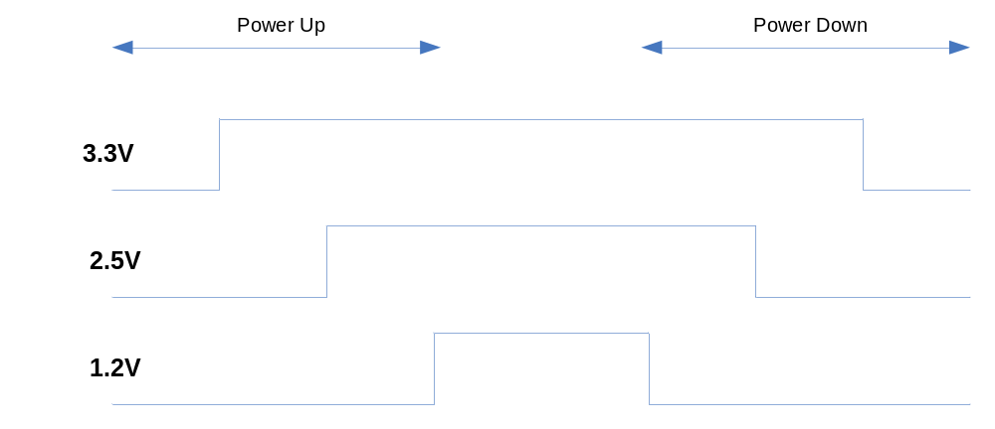

PLL Application

Table 3- PLL Power Description
PLL_DVSS | power | PLL Dedicated Digital ground
PLL_DVDD | power | PLL Dedicated Digital power supply +1.2V
PLL_IOVSS | power | PLL IO ground
PLL_IOVDD | power | PLL 1.2V IO Power
PLL_AVSS | power | PLL Dedicated Analog ground
PLL_AVDD | power | PLL Dedicated Analog power supply +1.2V

Figure 3- PLL Connection Diagram
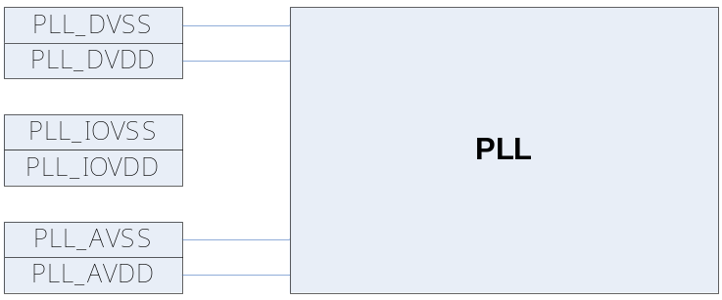

Figure 3- Tank Circuit for the Fundamental Mode Oscillation
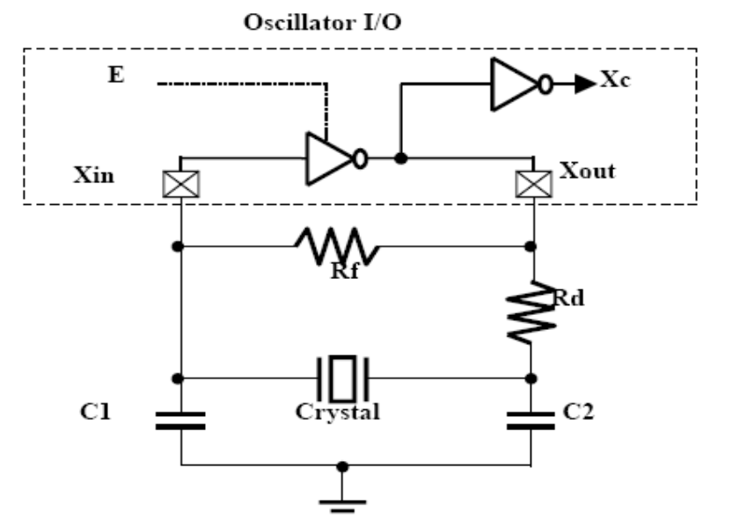
CL = 8pF
Maximum ESR = 40 ohm

Figure 3-1 shows several components that decide the behavior of oscillation, and they affect the loop in many aspects:

• Rf represents the feedback resistor to bias the inverter in the high gain region. Rf cannot be too low, or the loop may fail to oscillate. Normally, an Rf of 1MOhm is sufficient for MHz band applications.

• Rd represents the damping resistor that helps increase stability, save power, and suppress the gain in the high frequency area. The trade-off for inserting Rd is the reduction of negative resistance. Therefore, Rd cannot be too large, or the loop could fail to oscillate. Sometimes users may drop Rd in high frequency applications to reduce production costs.

• C1 and C2 are decided according to the crystal or resonator CL specification. In the steady state of oscillating, CL is defined as (C1 x C2)/(C1+C2). In fact, the I/O ports, the bond pad, and package pin all contribute the parasitic capacitance to C1 and C2. Therefore, we can rewrite CL to be (C1* x C2*)/(C1*+C2*), where C1*=(C1+C_{in, stray}) and C2*=(C2+C_{out, stray}). In this example, the required C1 and C2 would be reduced.

DDR Application

Table 3- Pin Name of SSTL2 Power and Ground Cells
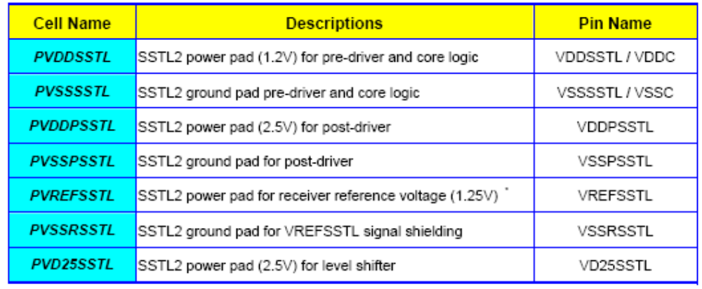

V_{REF} on board or VREFSSTL in the chip are both sensitive to coupling noise.
On the board, it’s suggested to provide the V_{DDQ}/V_{SS} traces shielding to the V_{REF} trace in parallel.

Figure 3- SSTL2 POC signal waveforms
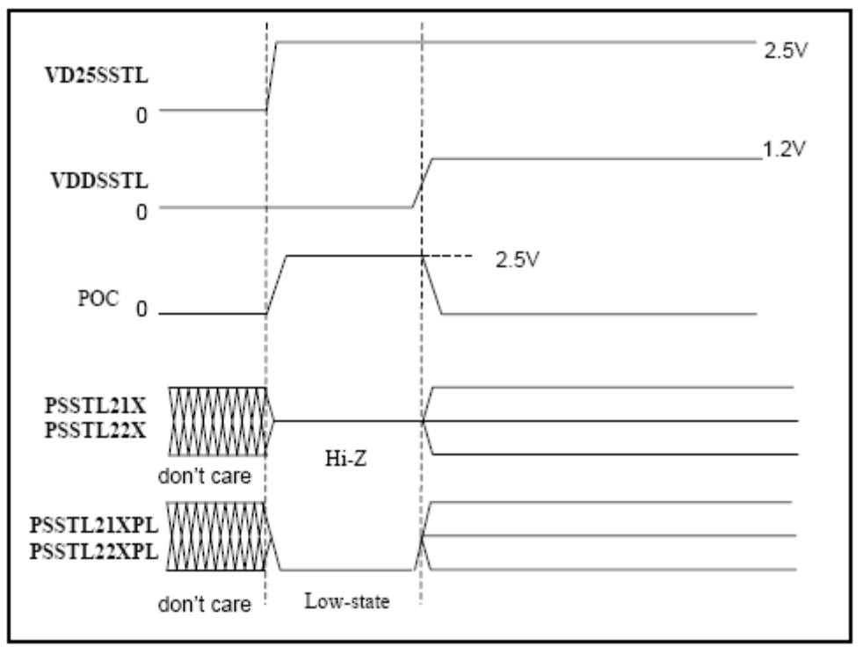

The POC circuit is located inside the PVD25POCSSTL cell. This PVD25POCSSTL cell has the same role as the PVD25SSTL cell (to provide “high” voltage to the I/O ring). The POC detects a power-on condition and derives a signal (also named POC) for distribution to the rest of the I/Os Power-up Sequence

To avoid any damage on the ESD device during power-on, user must obey the TSMC’s power-up sequence as defined in stdandard library application notes. 2.5V power for both PVDDPSSTL and PVD25SSTL need to be turned on before the other power voltages. 1.2V power supply for PVDDSSTL and 1.25V for PVREFSSTL must be on once 2.5V power supplies are fully turned on

Figure 3- SSTL2 Class I termination configuration
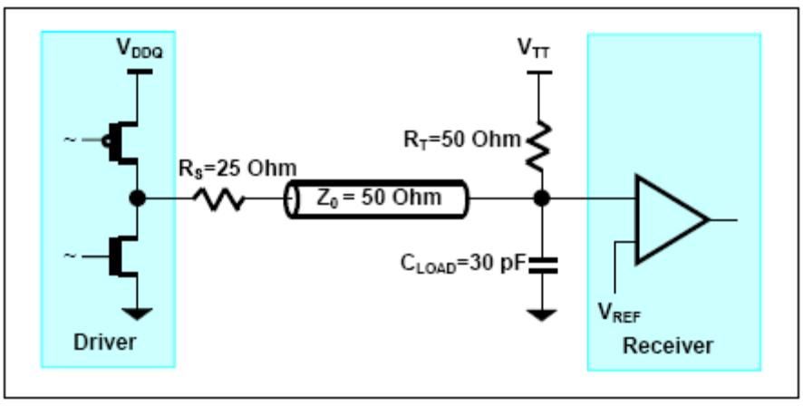

SSTL2 Class I transceiver is suitable for point-to-point application that has the transmission line characteristic impedance (Z₀) to be 50 Ohm. To reduce the reflection of the transmission line effect, the parallel termination resistor (R_{T}) should match to the line characteristic impedance, which is also 50 Ohm. The configuration of the connection from driver to receiver and its termination is shown in Figure3-3.

ARM ICE Application

MultiICE pin connections

Figure 3- MultiICE pin connections
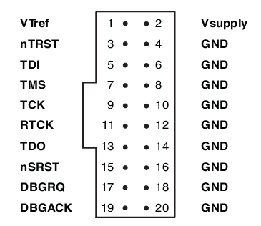

Signals

Table 3- MultiICE signals
Signal Name | I/O | Description
VTref | I | Target reference voltage.  RTCK와 TDO의 logic-level의 기준 전압을 알려준다.
Vsupply | I | MultiICE의 target보드쪽에서의 공급 전원.
(ARMICE_)nTRST | O | JTAG reset
(ARMICE_)TDI | O | JTAG data output to target cpu
(ARMICE_)TMS | O | JTAG test mode signal
(ARMICE_)TCK | O | JTAG JTAG test clock
(ARMICE_)RTCK | I | Return test clock
(ARMICE_)TDO | I | JTAG data input from target cpu
(ARMICE_)nSRST | I/O | All system is reset.  이 신호는 option으로 사용비중은 높으나 필수 신호는 아니다.
DBGRQ | O | Debug request. Not used in the MultiICE.
DBGACK | I | Debug acknowledge. Not used in the MultiICE.

Schematic

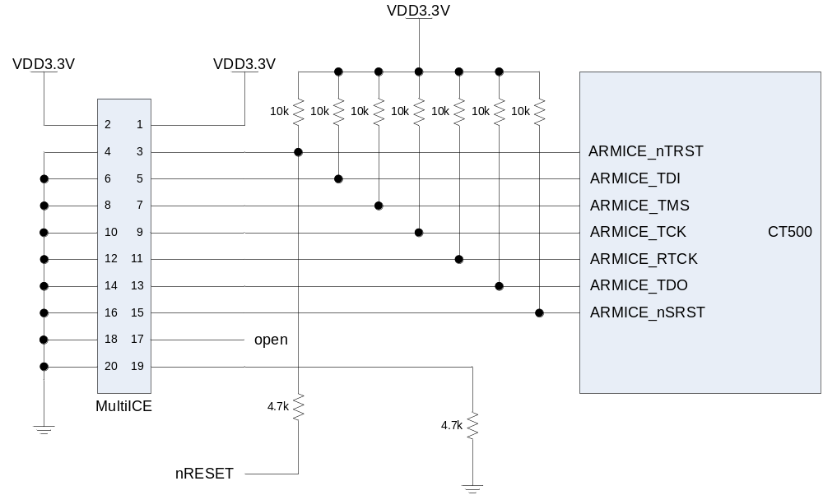

- CT500의 IO전압이 3.3V이므로 Vsupply와 VTref에 3.3V를 공급한다.
- nRESET은 system reset으로 CT500이 reset될 때 JTAG control block도 reset시킨다.
DBGRQ와 DBACK는 ARM MultiICE에서는 사용하지 않으므로 입력신호만 pulldown시킨다.

USB Application

Board Application

Figure 3- PCB Schematic
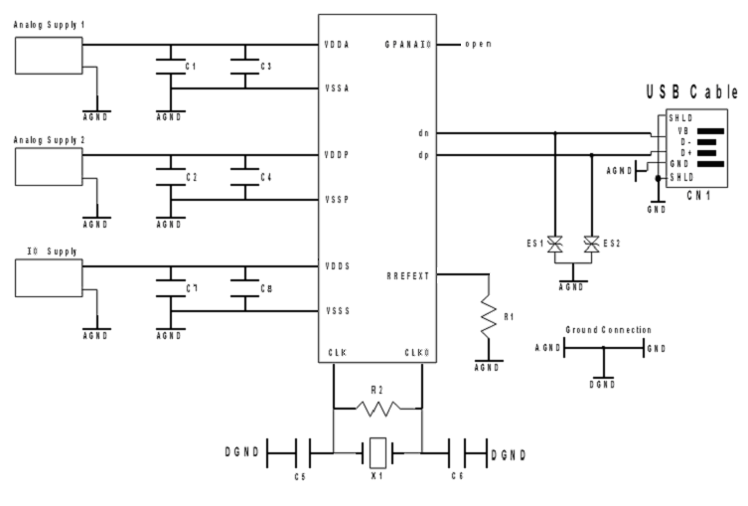

Analog Supply 1 : 3.3V
Analog Supply 2 : 1.2V
IO Supply : 3.3V
R1(reference resistor) : 6.04kohm 오차 1%
X1 : 24Mhz
C5, C6 : 22pF
R2 : 1Mohm
C1, C2, C7 : 100nF
C3, C4, C8 : 1nF

Table 3- USB Pin Name Mapping
Pin Name | Schematic Name | Description
USB_vdda | VDDA | USB PHY Analog core 3.3V
USB_vdds | VDDS | USB PHY IO ring power 3.3V
USB_DN | dn | Negative output channel that is connected to the serial USB cable
USB_DP | dp | Positive output channel that is connected to the serial USB cable
USB_vssa | VSSA | USB PHY Analog core ground
USB_vsss | VSSS | USB PHY IO ring ground
USB_rrefext | RREFEXT | USB PHY External resistor connection for current reference
USB_gpanaio | GPANAIO | USB PHY Test Pins for Observability of Internal Analog Signals
USB_vddp | VDDP | USB PLL 1.2V
USB_vssp | VSSP | USB PLL ground

PCB Layout

USB 2.0 data signal line은 parallel하게 배치 해야 하며 그 간격을 일정하게 유지해야 한다.
각 line의 impedance는 45ohm, 두 line간의 impedance는 90ohm을 이루도록 해야 한다.

Figure 3- PCB Layout for USB 2.0 signal lines
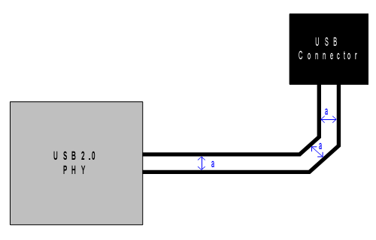

USB signal과 다른 signal과 crosstalk을 최소화 하기 위하여 다음 Figure와 같이 간격을 두어야 한다.

Figure 3- Space of USB 2.0 signal lines
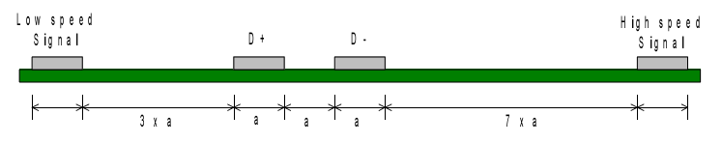

USB 2.0 PHY와 connector간의 거리는 457mm 이내가 되어야 한다.

USB 2.0 data line에 resistor를 연결할 때에는 stub이 발생하지 않게 하기 위해서 아래 Figure와 같이 연결한다.

Figure 3- Component to USB 2.0 signal lines
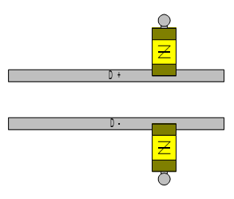

USB 2.0 data line을 ground plane으로 감쌀경우에는 하나의 plane으로 해야 하며 여러 개의 Plane으로 나뉘어지면 안 된다.

Figure 3- USB 2.0 signal and ground plane
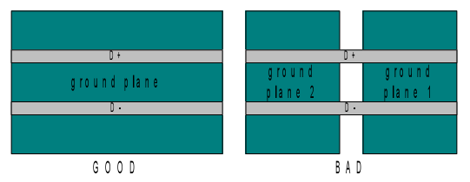

Crystal은 다음 Figure와 같이 ground plane으로 주위를 감싼다.

Figure 3- USB Crystal
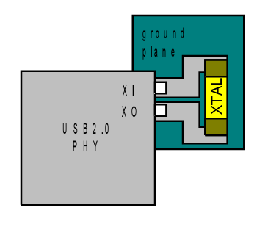

DAC Application

Overview

This is 10-bit single Video DAC. The circuit is a current output DAC designed to be loaded by double terminated 75 Ohm lines

Feature

- 10bit Resolution
- 27Mhz Update Rate
- Full-scale Output Currents : 17/34mA
- 2.43V to 3.6V Analog Power Supply
- 1.08V to 1.32V Digital Power Supply

Block diagram

Figure 3- Video DAC Diagram
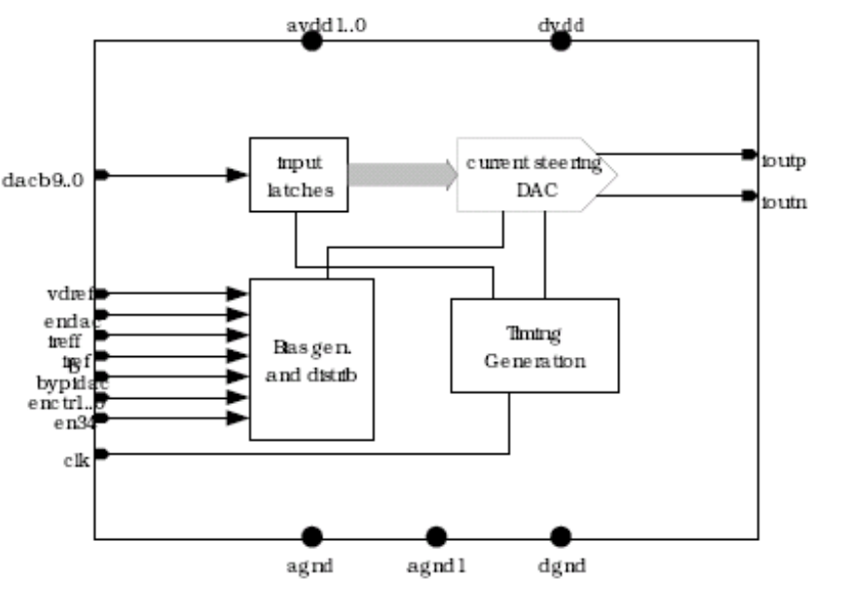

Operation

Operation mode setting

Table 3- Operation mode
Mode | Description | Configuration
Mode | Description | EN_DAC0 | EN_DAC0_34 | BYPIDAC
0 | Complete Power Down | 0 | X | X
1 | Normal mode, 17mA output full scale mode | 1 | 0 | 0
2 | Normal mode, 34mA output full scale mode | 1 | 1 | 0
3 | DAC is active | 1 | X | 0
4 | DAC active, using external reference currents | 1 | X | 1

기본적으로 External Bias mode 와 Internal Bias mode로 구분됩니다. 각 설정 register는 Video Encoder (Video Encoder Control reg.)를 통하여 설정 할 수 있습니다.

mode 0

모든 전원을 차단한 상태 입니다. EN_DAC0를 ‘LOW’ 설정함으로써 다른 설정에 관계없이 Power-Down mode로 설정 됩니다.

mode 1/2

Internal Bias mode를 사용하며, mode1에 경우에는 17mA로 출력 전류를 구동합니다. 출력 전류 선택은 EN_DAC_34를 통하여 설정할 수 있습니다. (Rref :: 1150 Ohm)

Figure 3- mode1/2 iref connection
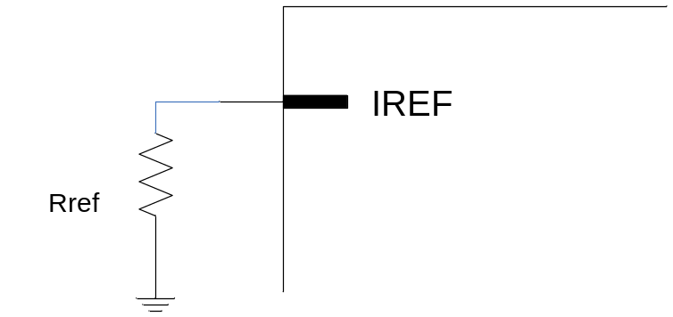

mode 4

External Bias mode를 사용하는 경우 입니다.

Figure 3- mode4 iref connection
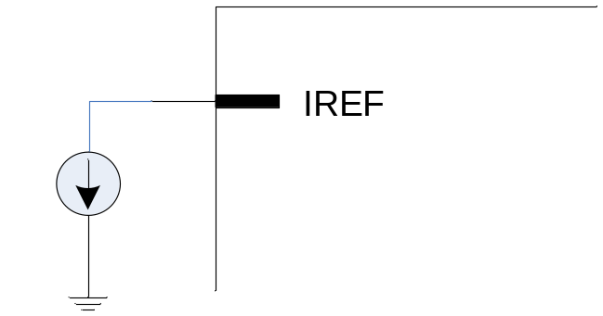

PCB guidelines

Power supply decoupling

Figure 3- power supply decoupling
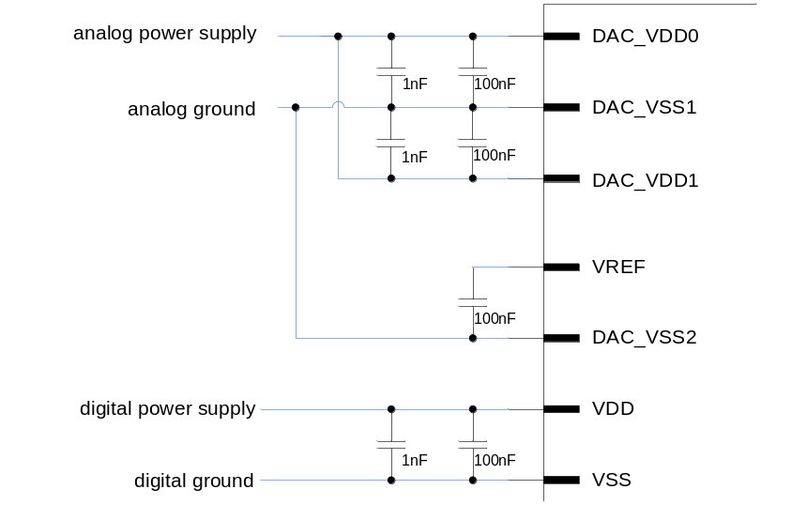
100nF cap은 가능한 칩에 가까이 위치하고, 특성이 좋은 소자를 사용합니다.

Analog output configuration

Figure 3- simple configuration to implement output to voltage conversion
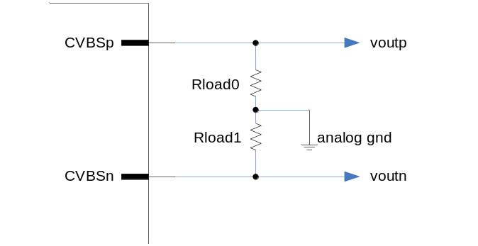
전압 출력에 간단한 예 입니다. 저항 값은 출력되는 전압 폭을 고려하여 설정합니다. 34mA(EN_DAC0_34 = ‘High’) 전류 폭을 갖도록 설정 할 경우 Rload0/Rload1 이 37.5 Ohm이면 ±1.275V 폭을 갖게 됩니다.

Figure 3- 34mA output configuration to convert current to voltage (Normal)
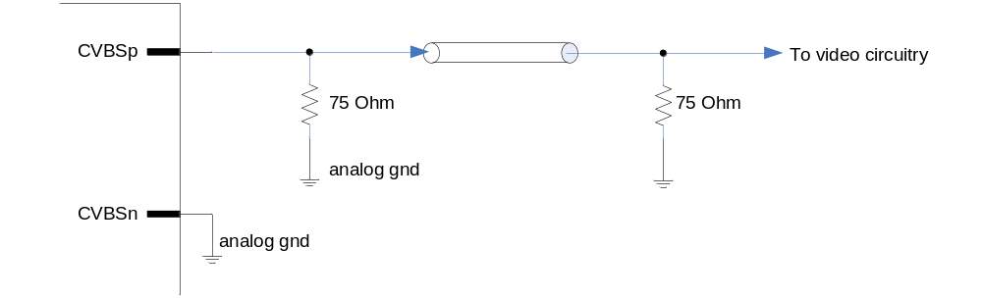
가장 일반적인 경우에 Video output 출력을 보여 줍니다. 종단 저항은 37.5 Ohm 인 경우이며, EN_DAC0_34 = ‘High’ 설정하였을 경우 입니다. 위와 같은 경우에 출력 전압 폭은 1.275V 가 됩니다.

Figure 3- 17mA output configuration to convert current to voltage
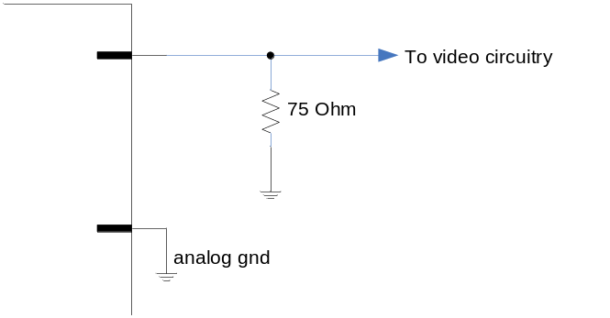
EN_DAC0_34 = ‘Low’ 설정하였을 경우 입니다. 출력 전류 폭이 17mA로 설정되고 전압 폭은 1.275V 입니다.

Figure 3- Reference guideline
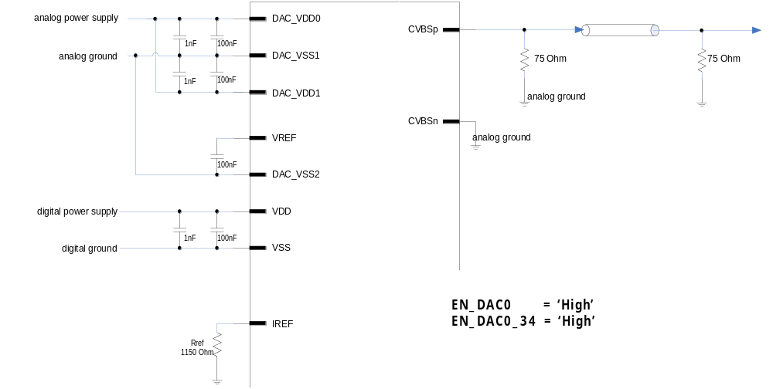
34mA 출력 전류 폭을 갖는 것을 기본으로 하며 Rref 는 1150 Ohm을 사용합니다.

